Oceans Story Board

**Fist Panel**

Title: Tropical Oceans

Text: 76% of the Tropics is Ocean

Only 6% of territorial waters is under some form of protection from fishing and other activities

Image:

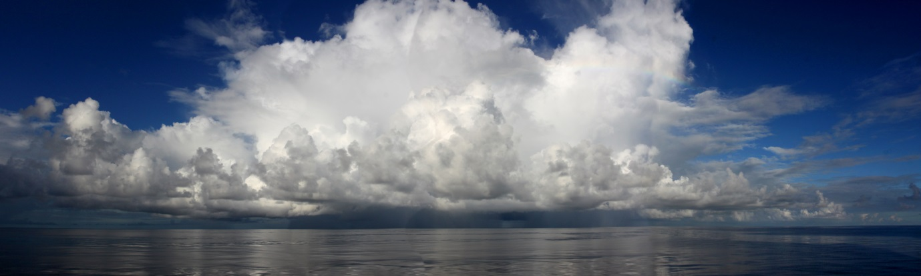

**Second Panel:**

Title: Wild marine catch

Text: Fish are the primary source of animal protein for many coastal communities worldwide, especially in the tropics. While global fish catch peaked in the 1990s and has since declined, catches in the Tropics have continued to increase. Almost 50% of global catch now occurs in the Tropics.





**Third Panel**

Title: Aquaculture production

Responsible aquaculture represents the best hope of meeting demand for fish based protein and halting the decline of wild stocks. However the rapid growth of aquaculture in the Tropics (particularly high intensity mono-cultures) has had some negative environmental effects. Greater emphasis on sustainable poly-cultures and better environmental practices are will contribute to a better future for the Tropics.



**Fourth Panel**

Title: Coral reefs

The vast majority of coral reefs are tropical. Coral reefs are important for fisheries, provide protection to coasts and are an important source of income through tourism. Threats to coral reefs have increased markedly over the past two decades. Coral reefs in all tropical regions are suffering from increased local and global threats including coastal development, over-fishing, pollution, increasing water temperatures and ocean acidification.





**Fifth Panel:**

Title: Mangrove forests

The Tropics host nearly 95% of the world’s mangrove forests. All tropical regions have suffered declines since 1980 and it is estimated that up to 50% of mangrove forests were lost before that. The greatest threats to mangroves include forestry, coastal development, aquaculture and pollution.

